Access control

We have implemented access control on all access doors through people who have privileges to allow them to go into the office/room, and there are privileges defined by management

There are samples for access control to Data Center & Storage room

Data center: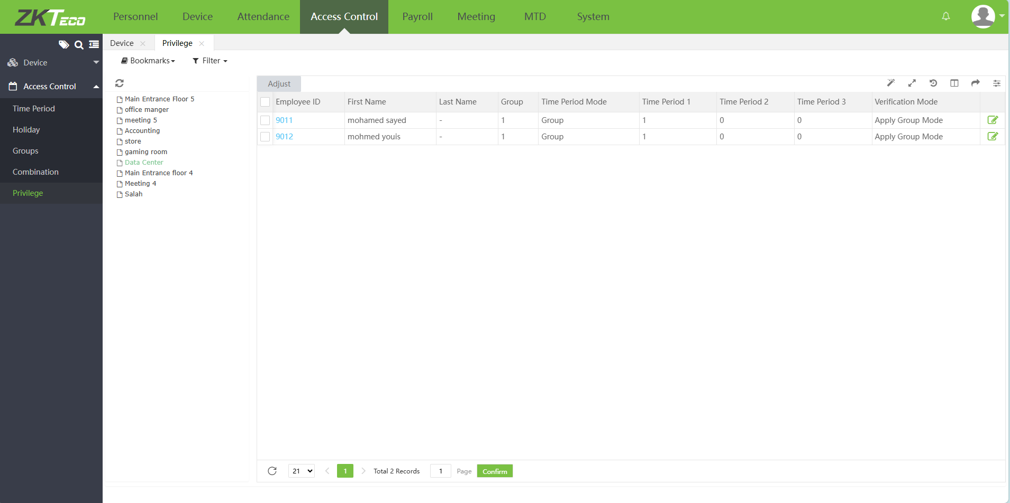

Store room:

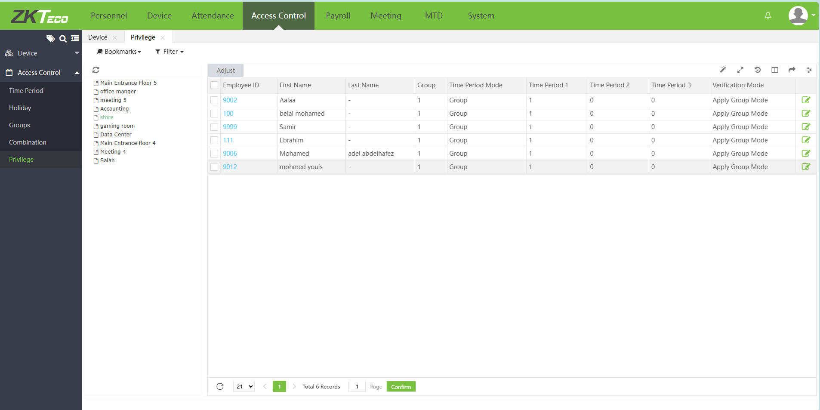

Access logs are reviewed by IT Team